TASK 1:
#include <iostream>
#include <limits>

using namespace std;

const int NumVertices = 6;
const int MaxValue = numeric_limits<int>::max();

int findMinDistIndex(int dist[], bool visited[]) {
int minKey = MaxValue;
int minIndex = -1;

for (int v = 0; v < NumVertices; ++v) {
if (!visited[v] && dist[v] < minKey) {
minKey = dist[v];
minIndex = v;
}
}
return minIndex;
}

void printShortestPath(int parent[], int j) {
if (parent[j] == -1)
return;

printShortestPath(parent, parent[j]);
cout << j << " ";
}

void printResult(int dist[], int parent[], int source, int destination) {
cout << "Shortest Path from " << source << " to " << destination << " with distance " << dist[destination] << " is: " << endl;
printShortestPath(parent, destination);
cout << endl;
}

void findShortestPath(int graph[NumVertices][NumVertices], int source, int destination) {
int dist[NumVertices];
bool visited[NumVertices];
int parent[NumVertices];

for (int i = 0; i < NumVertices; ++i) {
dist[i] = MaxValue;
visited[i] = false;
parent[i] = -1;
}
dist[source] = 0;

for (int count = 0; count < NumVertices - 1; ++count) {
int u = findMinDistIndex(dist, visited);
visited[u] = true;

for (int v = 0; v < NumVertices; ++v) {
if (!visited[v] && graph[u][v] && dist[u] != MaxValue) {
if (dist[u] + graph[u][v] < dist[v]) {
parent[v] = u;
dist[v] = dist[u] + graph[u][v];
}
}
}
}
printResult(dist, parent, source, destination);
}

int main() {
int weightGraph[NumVertices][NumVertices] = {
{0, 1, 0, 5, 0, 0},
{0, 0, 2, 2, 1, 0},
{0, 0, 0, 0, 3, 1},
{0, 0, 0, 0, 2, 0},
{0, 0, 0, 0, 0, 2},
{0, 0, 0, 0, 0, 0}
};

int srcNode = 0;
int destNode = 5;

findShortestPath(weightGraph, srcNode, destNode);

return 0;
}

OUTPUT:
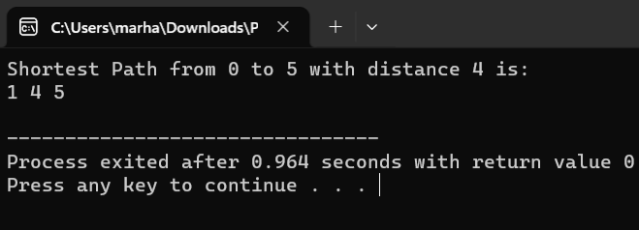

TASK 2:
#include<iostream>

using namespace std;

class Node {
public:
int value;
Node* next;

Node(int val) {
this->value = val;
this->next = NULL;
}
};

class GraphList {
private:
int totalNodes;
Node** nodes;

public:
GraphList(int totalNodes) {
this->totalNodes = totalNodes;

nodes = new Node*[totalNodes];
for (int i = 0; i < totalNodes; ++i) {
nodes[i] = NULL;
}
}

void addConnection(int start, int end) {
Node* newNode = new Node(end);
newNode->next = nodes[start];
nodes[start] = newNode;

newNode = new Node(start);
newNode->next = nodes[end];
nodes[end] = newNode;
}

void displayGraph() {
for (int i = 0; i < totalNodes; ++i) {
cout << "Node " << i << ": ";
Node* current = nodes[i];
while (current != NULL) {
cout << current->value << " ";
current = current->next;
}
cout << endl;
}
}
};

int main() {
int totalNodes = 5;
int totalConnections = 7;

int connections[][2] = {{0, 1}, {0, 4}, {4, 1}, {4, 3}, {1, 3}, {1, 2}, {3, 2}};

GraphList graph(totalNodes);

for (int i = 0; i < totalConnections; ++i) {
graph.addConnection(connections[i][0], connections[i][1]);
}

cout << "Displaying the Graph:" << endl;
graph.displayGraph();

return 0;
}

OUTPUT:
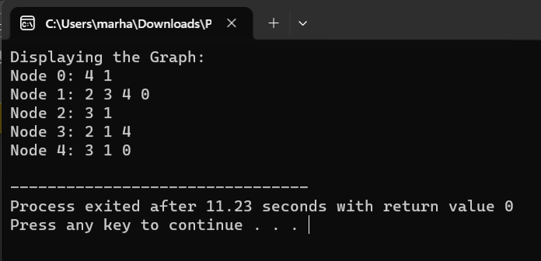

TASK 3:
#include<iostream>

using namespace std;

const int NumNodes = 3;
const int InfiniteValue = 1e9;

int minIndex;

int findMinKeyValue(int key[], bool visited[]) {
int minKey = InfiniteValue;
minIndex = -1;

for (int node = 0; node < NumNodes; ++node) {
if (!visited[node] && key[node] < minKey) {
minKey = key[node];
minIndex = node;
}
}
return minIndex;
}

int displayMinimumSpanningTree(int parent[], int graph[NumNodes][NumNodes]) {
int totalWeight = 0;
for (int i = 1; i < NumNodes; ++i) {
cout << "Selected Edge: " << parent[i] << " - " << i << " with Weight: " << graph[i][parent[i]] << endl;
totalWeight += graph[i][parent[i]];
}
cout << "Total Weight of Minimum Spanning Tree: " << totalWeight << endl;
return totalWeight;
}

void primMinimumSpanningTree(int graph[NumNodes][NumNodes]) {
int parent[NumNodes];
int key[NumNodes];
bool visited[NumNodes];

for (int i = 0; i < NumNodes; ++i) {
key[i] = InfiniteValue;
visited[i] = false;
}

key[0] = 0;
parent[0] = -1;

for (int count = 0; count < NumNodes - 1; ++count) {
int u = findMinKeyValue(key, visited);
visited[u] = true;

for (int v = 0; v < NumNodes; ++v) {
if (graph[u][v] && !visited[v] && graph[u][v] < key[v]) {
parent[v] = u;
key[v] = graph[u][v];
}
}
}
int totalWeight = displayMinimumSpanningTree(parent, graph);
}

int main() {
int weightGraph[NumNodes][NumNodes] = {
{0, 1, 5},
{4, 0, 3},
{5, 3, 0}
};

cout << "Applying Prim's Algorithm to find Minimum Spanning Tree:" << endl << endl;
primMinimumSpanningTree(weightGraph);

return 0;
}
OUTPUT:
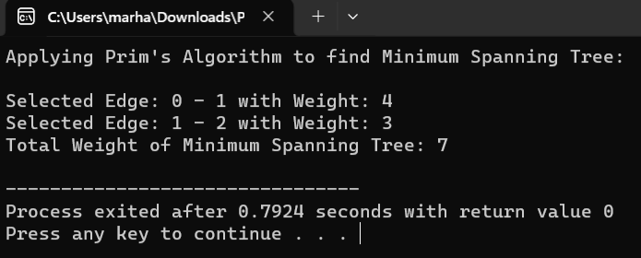

TASK 4:
#include<iostream>
#include<climits>

using namespace std;

class DijkstraAlgorithm {
int numNodes, numEdges;
int* nodeDistances;

public:
DijkstraAlgorithm(int nodes, int edges) {
numNodes = nodes;
numEdges = edges;
nodeDistances = new int[nodes];
}

void calculateShortestPaths(int graph[50][3], int startNode) {
cout << "Calculating Shortest Paths using Dijkstra's Algorithm..." << endl;

for (int i = 0; i < numNodes; ++i) {
nodeDistances[i] = INT_MAX;
}
nodeDistances[startNode] = 0;

for (int iteration = 0; iteration < numNodes - 1; ++iteration) {
for (int edgeIndex = 0; edgeIndex < numEdges; ++edgeIndex) {
int sourceNode = graph[edgeIndex][0];
int destinationNode = graph[edgeIndex][1];
int edgeWeight = graph[edgeIndex][2];

if (nodeDistances[sourceNode] != INT_MAX && nodeDistances[sourceNode] + edgeWeight < nodeDistances[destinationNode]) {
nodeDistances[destinationNode] = nodeDistances[sourceNode] + edgeWeight;
}
}
}

for (int edgeIndex = 0; edgeIndex < numEdges; ++edgeIndex) {
int sourceNode = graph[edgeIndex][0];
int destinationNode = graph[edgeIndex][1];
int edgeWeight = graph[edgeIndex][2];

if (nodeDistances[sourceNode] != INT_MAX && nodeDistances[sourceNode] + edgeWeight < nodeDistances[destinationNode]) {
cout << "Graph contains negative weight cycle. Unable to find shortest paths." << endl;
return;
}
}

cout << "Shortest Distances from the Start Node (" << startNode << "):" << endl;
for (int i = 0; i < numNodes; ++i) {
if (nodeDistances[i] == INT_MAX) {
cout << "Node " << i << ": Infinite" << endl;
} else {
cout << "Node " << i << ": " << nodeDistances[i] << endl;
}
}
}
};

int main() {
int nodes = 3;
int edges = 4;
int weightedGraph[50][3] = {{0, 1, 5}, {1, 0, 3}, {1, 2, -1}, {2, 0, 1}};
int startNode = 2;

DijkstraAlgorithm dijkstra(nodes, edges);

dijkstra.calculateShortestPaths(weightedGraph, startNode);

return 0;
}

OUTPUT:
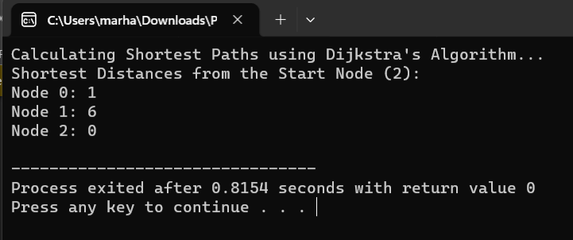
TASK 5:
#include<iostream>

using namespace std;

class SimpleQueue {
private:
static const int MAX_SIZE = 1000; // Set a maximum size for the queue
int arr[MAX_SIZE];
int front, rear;

public:
SimpleQueue() : front(-1), rear(-1) {}

bool isEmpty() {
return (front == -1 && rear == -1);
}

bool isFull() {
return (rear + 1) % MAX_SIZE == front;
}

void enqueue(int value) {
if (isFull()) {
cout << "Queue is full. Cannot enqueue." << endl;
return;
}

if (isEmpty()) {
front = rear = 0;
} else {
rear = (rear + 1) % MAX_SIZE;
}

arr[rear] = value;
}

int dequeue() {
if (isEmpty()) {
cout << "Queue is empty. Cannot dequeue." << endl;
return -1;
}

int removedValue = arr[front];

if (front == rear) {
front = rear = -1;
} else {
front = (front + 1) % MAX_SIZE;
}

return removedValue;
}
};

class IslandExplorer {
public:
int countIslands(int map[50][50], int numRows, int numCols) {
int islandCount = 0;

for (int i = 0; i < numRows; ++i) {
for (int j = 0; j < numCols; ++j) {
if (map[i][j] == 1) {
exploreIsland(map, i, j, numRows, numCols);
islandCount += 1;
}
}
}
return islandCount;
}

void exploreIsland(int map[50][50], int x, int y, int numRows, int numCols) {
SimpleQueue islandQueue;
islandQueue.enqueue(x * numCols + y);

while (!islandQueue.isEmpty()) {
int currentCell = islandQueue.dequeue();
int currentX = currentCell / numCols;
int currentY = currentCell % numCols;

if (currentX < 0 || currentX >= numRows || currentY < 0 || currentY >= numCols || map[currentX][currentY] != 1)
continue;

map[currentX][currentY] = 2; // Marking the island as visited

// Adding adjacent cells to the queue
islandQueue.enqueue((currentX + 1) * numCols + currentY);
islandQueue.enqueue(currentX * numCols + currentY + 1);
islandQueue.enqueue((currentX - 1) * numCols + currentY);
islandQueue.enqueue(currentX * numCols + currentY - 1);
islandQueue.enqueue((currentX + 1) * numCols + currentY + 1);
islandQueue.enqueue((currentX - 1) * numCols + currentY - 1);
islandQueue.enqueue((currentX - 1) * numCols + currentY + 1);
islandQueue.enqueue((currentX + 1) * numCols + currentY - 1);
}
}
};

int main() {
int landMap[50][50] = {{0, 1}, {1, 0}, {1, 1}, {1, 0}};
int numRows = 4;
int numCols = 2;

IslandExplorer islandExplorer;

int numberOfIslands = islandExplorer.countIslands(landMap, numRows, numCols);

cout << "Number of Islands: " << numberOfIslands << endl;

return 0;
}
OUTPUT:
